### **Normalization of Database**

Database Normalization is a technique of organizing the data in the database.

* Normalization is a systematic approach of decomposing tables to eliminate data redundancy and undesirable characteristics like Insertion, Update and Deletion Anomalies.
* It is a multi-step process that puts data into tabular form by removing duplicated data from the relation tables.

Normalization is used for mainly two purpose,

* Eliminating redundant (useless) data
* Ensuring data dependencies make sense i.e data is logically stored

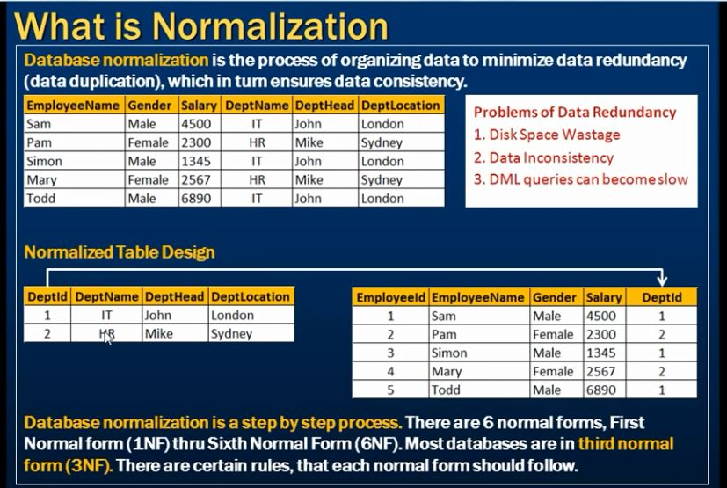

#### **Normalization Rule**

Normalization rule are divided into following normal form.

1. First Normal Form
2. Second Normal Form
3. Third Normal Form
4. BCNF

#### **First Normal Form (1NF)**

As per First Normal Form**, no two Rows of data must contain repeating group of information** i.e each set of column must have a unique value, such that multiple columns cannot be used to fetch the same row. Each table should be organized into rows, and each row should have a primary key that distinguishes it as unique.

The **Primary key** is usually a single column, but sometimes more than one column can be combined to create a single primary key. For example consider a table which is not in First normal form

**Student Table:**

|  |  |  |
| --- | --- | --- |
| **Student** | **Age** | **Subject** |
| Adam | 15 | Biology, Maths |
| Alex | 14 | Maths |
| Stuart | 17 | Maths |

**In First Normal Form,** any row must not have a column in which more than one value is saved, like separated with commas. Rather than that, we must separate such data into multiple rows.

**Student Table following 1NF will be:**

|  |  |  |
| --- | --- | --- |
| Student | Age | Subject |
| Adam | 15 | Biology |
| Adam | 15 | Maths |
| Alex | 14 | Maths |
| Stuart | 17 | Maths |

Using the First Normal Form, data redundancy increases, as there will be many columns with same data in multiple rows but each row as a whole will be unique.

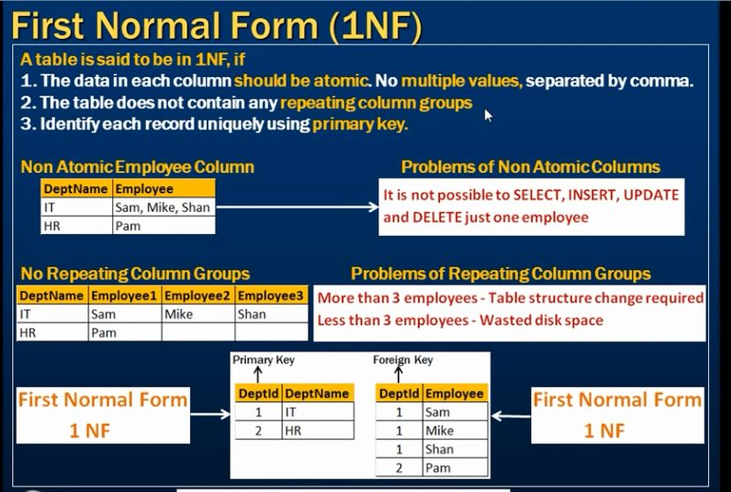

#### **Second Normal Form (2NF)**

Before we learn about the second normal form, we need to understand the following

* **Prime attribute** − An attribute, which is a part of the prime-key, is known as a prime attribute.
* **Non-prime attribute** − An attribute, which is not a part of the prime-key, is said to be a non-prime attribute.

If we follow second normal form, then **every non-prime attribute should be fully functionally dependent on prime key attribute**. That is, if X → A holds, then there should not be any proper subset Y of X, for which Y → A also holds true.

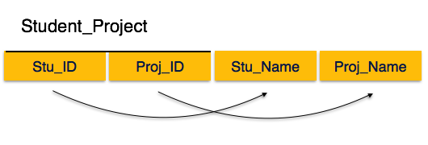

We see here in Student_Project relation that the prime key attributes are Stu_ID and Proj_ID. According to the rule, non-key attributes, i.e. Stu_Name and Proj_Name must be dependent upon both and not on any of the prime key attribute individually. But we find that Stu_Name can be identified by Stu_ID and Proj_Name can be identified by Proj_ID independently. This is called **partial dependency**, which is not allowed in Second Normal Form.

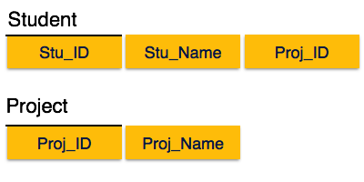

We broke the relation in two as depicted in the above picture. So there exists no partial dependency.

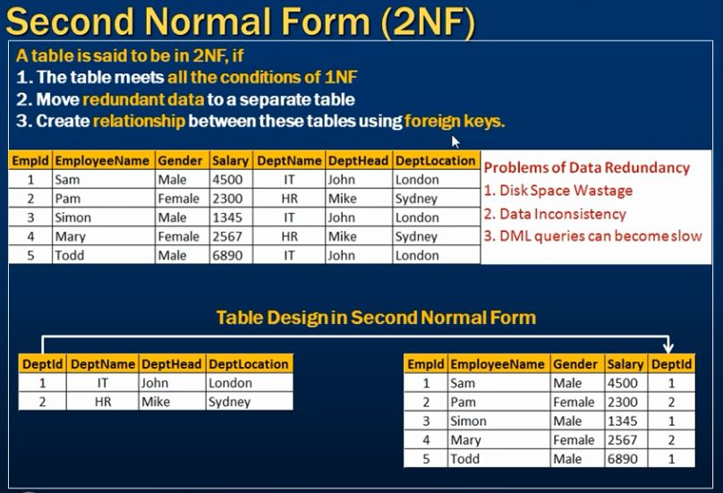

#### Third Normal Form (3NF)

For a relation to be in Third Normal Form, it must be in Second Normal form and the following must satisfy −

* No non-prime attribute is transitively dependent on prime key attribute.
* For any non-trivial functional dependency, X → A, then either −
  + X is a superkey or,
  + A is prime attribute.

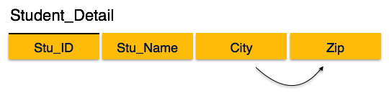

We find that in the above Student_detail relation, Stu_ID is the key and only prime key attribute. We find that City can be identified by Stu_ID as well as Zip itself. Neither Zip is a superkey nor is City a prime attribute. Additionally, Stu_ID → Zip → City, so there exists **transitive dependency**.

To bring this relation into third normal form, we break the relation into two relations as follows −

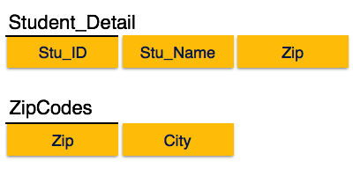

For example, consider a table with following fields.

**Student_Detail Table :**

|  |  |  |  |  |  |  |
| --- | --- | --- | --- | --- | --- | --- |
| **Student_id** | **Student_name** | **DOB** | **Street** | **city** | **State** | **Zip** |

In this table Student_id is Primary key, but street, city and state depends upon Zip. The dependency between zip and other fields is called **transitive dependency**. Hence to apply **3NF**, we need to move the street, city and state to new table, with **Zip** as primary key.

**New Student_Detail Table :**

|  |  |  |  |
| --- | --- | --- | --- |
| **Student_id** | **Student_name** | **DOB** | **Zip** |

**Address Table :**

|  |  |  |  |
| --- | --- | --- | --- |
| **Zip** | **Street** | **city** | **state** |

The advantage of removing transitive dependency is,

* Amount of data duplication is reduced.
* Data integrity achieved.

.**Example**: Suppose a company wants to store the complete address of each employee, they create a table named employee_details that looks like this:

|  |  |  |  |  |  |
| --- | --- | --- | --- | --- | --- |
| **emp_id** | **emp_name** | **emp_zip** | **emp_state** | **emp_city** | **emp_district** |
| 1001 | John | 282005 | UP | Agra | Dayal Bagh |
| 1002 | Ajeet | 222008 | TN | Chennai | M-City |
| 1006 | Lora | 282007 | TN | Chennai | Urrapakkam |
| 1101 | Lilly | 292008 | UK | Pauri | Bhagwan |
| 1201 | Steve | 222999 | MP | Gwalior | Ratan |

**Super keys**: {emp_id}, {emp_id, emp_name}, {emp_id, emp_name, emp_zip}…so on  
**Candidate Keys**: {emp_id}  
**Non-prime attributes**: all attributes except emp_id are non-prime as they are not part of any candidate keys.

Here, emp_state, emp_city & emp_district dependent on emp_zip. And, emp_zip is dependent on emp_id that makes non-prime attributes (emp_state, emp_city & emp_district) transitively dependent on super key (emp_id). This violates the rule of 3NF.

To make this table complies with 3NF we have to break the table into two tables to remove the transitive dependency:

**employee table:**

|  |  |  |
| --- | --- | --- |
| **emp_id** | **emp_name** | **emp_zip** |
| 1001 | John | 282005 |
| 1002 | Ajeet | 222008 |
| 1006 | Lora | 282007 |
| 1101 | Lilly | 292008 |
| 1201 | Steve | 222999 |

**employee_zip table:**

|  |  |  |  |
| --- | --- | --- | --- |
| **emp_zip** | **emp_state** | **emp_city** | **emp_district** |
| 282005 | UP | Agra | Dayal Bagh |
| 222008 | TN | Chennai | M-City |
| 282007 | TN | Chennai | Urrapakkam |
| 292008 | UK | Pauri | Bhagwan |
| 222999 | MP | Gwalior | Ratan |

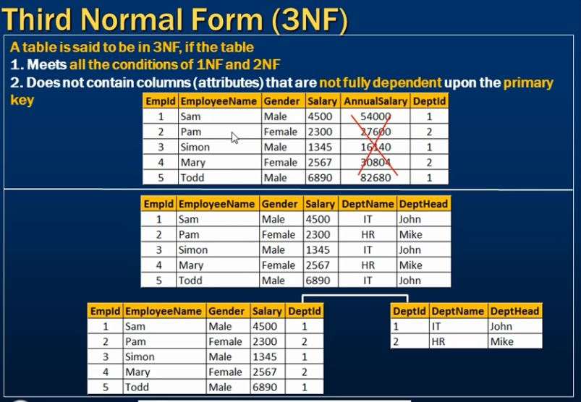

#### **Boyce and Codd Normal Form (BCNF)**

Boyce-Codd Normal Form (BCNF) is an extension of Third Normal Form on strict terms. BCNF states that −

* For any non-trivial functional dependency, X → A, X must be a super-key.

In the above image, Stu_ID is the super-key in the relation Student_Detail and Zip is the super-key in the relation ZipCodes. So,

Stu_ID → Stu_Name, Zip

and

Zip → City

Which confirms that both the relations are in BCNF.

**Example**: Suppose there is a company wherein employees work in **more than one department**. They store the data like this:

|  |  |  |  |  |
| --- | --- | --- | --- | --- |
| **emp_id** | **emp_nationality** | **emp_dept** | **dept_type** | **dept_no_of_emp** |
| 1001 | Austrian | Production and planning | D001 | 200 |
| 1001 | Austrian | stores | D001 | 250 |
| 1002 | American | design and technical support | D134 | 100 |
| 1002 | American | Purchasing department | D134 | 600 |

**Functional dependencies in the table above**:  
emp_id -> emp_nationality  
emp_dept -> {dept_type, dept_no_of_emp}

**Candidate key**: {emp_id, emp_dept}

The table is not in BCNF as neither emp_id nor emp_dept alone are keys.

To make the table comply with BCNF we can break the table in three tables like this:  
**emp_nationality table:**

|  |  |
| --- | --- |
| **emp_id** | **emp_nationality** |
| 1001 | Austrian |
| 1002 | American |

**emp_dept table:**

|  |  |  |
| --- | --- | --- |
| **emp_dept** | **dept_type** | **dept_no_of_emp** |
| Production and planning | D001 | 200 |
| stores | D001 | 250 |
| design and technical support | D134 | 100 |
| Purchasing department | D134 | 600 |

**emp_dept_mapping table:**

|  |  |
| --- | --- |
| **emp_id** | **emp_dept** |
| 1001 | Production and planning |
| 1001 | stores |
| 1002 | design and technical support |
| 1002 | Purchasing department |

**Functional dependencies**:  
emp_id -> emp_nationality  
emp_dept -> {dept_type, dept_no_of_emp}

**Candidate keys**:  
For first table: emp_id  
For second table: emp_dept  
For third table: {emp_id, emp_dept}

This is now in BCNF as in both the functional dependencies left side part is a key.

# Third Normal Form Comparison of BCNF and 3NF

## BCNF or 3NF?

* + Relations in BCNF and 3NF
    - Relations in BCNF: no repetition of information
    - Relations in 3NF: problem of repetition of information
  + Decomposition in BCNF and in 3NF
    - It is always possible to decompose a relation into relations in 3NF and
      * the decomposition is lossless
      * dependencies are preserved
    - It is always possible to decompose a relation into relations in BCNF and
      * the decomposition is lossless
      * the information is not repeated